|  |  |
| --- | --- |
| Royal Geelong Yacht Club Logo. | Royal Geelong Yacht Club Inc.  Est 1859 |
| Trophy Deed of Gift. | |

|  |  |
| --- | --- |
| Trophy: | Robin Robbins Trophy |
| Presented by: | Robin Robbins |
| Date: |  |
| For: | Winner of the Last Event of the Season |
| Remarks / Revisions | Changed to exclude Red Division when the Red/Blue split occurred  2012: Changed to Combined Event (Was limited to Blue Division)  If won by same person three times, becomes owner of trophy.  Donor traditionally replaces trophy if it is retained. |
| Click [here](http://www.rgyc.com.au/honourboards/Cadet%20Last%20Race%20of%20the%20Season.pdf) for a List of the Recipients of the Current Trophy | |

Robin Robins joined the Club in 1945, being nominated by Wilfred Libby.

His first sailing experience was on Mr Libby’s “S.J.S.”, then sailing on the Club-Owned 12 foot cadet “Royal”.

Graduated to a Snipe class boat before contracted Higgs Bros to build “Desire”, a Tal-Searle designed boat.

Purchased a dragon from Fred Fitzgerald, renamed it “Thunderbird” and won the Dragon Championship in 1965-66.

Had a Searle 25 which he built and owned for 15 Years.

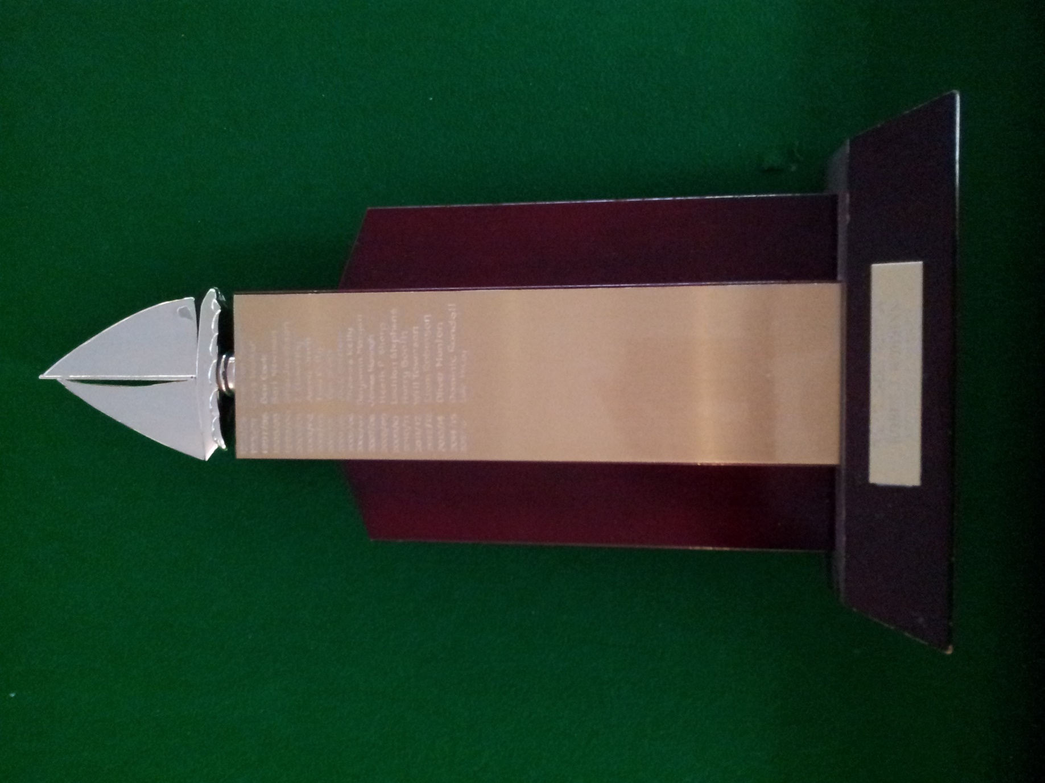

Robin Robins:

1930-2023